
Sentara Initial Integration with Saviynt High Level Design
Contents
Version history 6
1. Glossary 7
2. Introduction 9
2.1 Purpose of this document 10
2.2 Audience 10
2.3 Project Background 10
3. High Level Architecture for Phase 1 implementation 10
Detailed Explanation of the Components: 14
3.1 Assumptions: 15
3.2 Architecture Flow: User Onboarding 15
3.2.1 Workday As An Authoritative Source – Employee Onboarding 15
Assumptions 15
Design 16
Workday – Reconciliation approach 17
Workday – Saviynt Attribute Mapping 18
Data pre-processor 19
Account name Generation 19
Email Generation 20
Email Alias Generation 20
UTILITY: AccountName, Email and Email Proxy Address Generation 21
Jobs 22
3.2.2 SecZetta As An Authoritative Source 23
Assumptions 23
SecZetta– Reconciliation approach 24
Design Aspects 25
Data preprocessor 25
Account name Generation 25
Email Generation 25
Reconcile jobs 25
5. NEW HIRE 26
Enterprise role – Workday 27
Provisioning rules for new hire – Workday 28
Enterprise role – Based on SECZETTA 30
Provisioning rules for new hire- SecZetta 32
6. User update 32
Provisioning rules for user update 33
7. Termination 33
Provisioning rules for Termination 34
8. Persona based User management 35
Enterprise role based on persona 36
Provisioning rules for Persona Based access 38
9. Architecture Flow: User Rehire 38
Assumptions: 38
Provisioning rules for Rehire 39
10. User Suspension & Revoke Suspension 40
Assumptions: 40
Provisioning Rule Names 40
9.1 Immediate Termination 42
Assumptions: 42
Provisioning Rule Names 42
11. Active Directory Provisioning 43
10.1 Assumptions: 43
10.2 Prerequisites: 43
10.3 Connection Design 43
10.4 Saviynt-AD Import Attribute Mapping 44
10.5 AD Account Management Processes 44
Important Rules 44
User Events 44
12. ServiceNow Provisioning 46
11.1 Assumptions: 46
11.2 Prerequisite: 46
11.3 Connection Design 46
11.4 Saviynt-ServiceNow Attribute Mapping 46
11.5 ServiceNow Account Management Processes 47
Important Rules 47
User Events 47
13. Duo INTEGRATION (FULL) 48
12.1 Assumptions: 48
12.2 Prerequisite: 48
12.3 Connection Design 48
12.4 Saviynt-Duo Attribute Mapping 49
12.5 DUO Account and access Management Processes 49
Important Rules 50
User Events 50
14. PSDB Provisioning 51
14.1 Assumptions: 51
14.2 Prerequisite: 52
14.3 Connection Design 52
14.4 Saviynt-PSDB Import Attribute Mapping 52
14.5 PSDB Account Management Processes 53
Important Rules 53
User Events 53
15. SNOW Additional Provisioning 54
15.1 Assumptions: 54
15.2 Prerequisite: 54
15.3 Connection Design 54
15.4 Saviynt-ServiceNow Attribute Mapping 55
15.5 ServiceNow Account Management Processes 55
Important Rules 55
User Events 55
16. AD RBAC Additional Provisioning 56
16.1 Assumptions: 56
16.2 Prerequisite: 57
16.3 Connection Design 57
17. SIEM Integration 57
17.1 Assumptions: 57
17.2 Prerequisite: 57
17.3 Connection Design 58
18. PAM Integration with BeyondTrust 59
18.1 Assumptions: 59
18.2 Prerequisites: 59
18.3 Connection Design 59
18.4 Saviynt-AD Import Attribute Mapping 60
18.5 AD Account Management Processes 60
Important Rules 61
User Events 61
18.6 BeyondTrust Account Management Processes 62
Important Rules 62
User Events 62
19. Verity Integration 63
19.1 Assumptions: 63
19.2 Verity Reconciliation Approach 63
19.3 Connector Design 63
19.4 Data PreProcessor: 64
19.5 Account Name Generation: 64
19.6 Email Generation: 65
19.7 Reconciliation Jobs: 65
20. QNXT Provisioning 65
20.1 Assumptions: 65
20.2 Prerequisite: 66
20.3 Connection Design 66
20.4 Saviynt-QNXT Import Attribute Mapping 67
20.5 QNXT Account Management Processes 67
Important Rules 67
User Events 67
20.6 Reconciliation Jobs: 68
21. EPIC Provisioning 68
21.1 Assumptions: 69
21.2 Prerequisite: 69
21.3 Connection Design 69
2.14 Saviynt-EPIC EMP Import Attribute Mapping 70
21.5 Epic EMP Account Management Processes 72
Important Rules 73
User Events 73
21.6 Reconciliation Jobs: 73
4. EMAIL TEMPLATES 74
Assumptions 74
Welcome email/account claiming email sent to the end-user 74
Account expiration notice email sent to the relationship group 75
User termination email sent to the user's manager 76
1. Appendix 76

Version history

Version | Date | Comments
0.1 | 2/17/2023 | First draft by Saviynt
0.2 | 2/20/2023 | Formatting correction
0.3 | 3/6/2023 | Updates based on Onsite design discussion
Phase 2 | 05/01/2024 | Added the design section for Phase 2 integrations

Glossary

Saviynt Terminology | Description
ARS | Access Request System
HR | Human Resources
IGA | Identity Governance & Administration
SNOW | Service Now
OOTB | Out of the box
SSM | Saviynt Security Manager
Connection | A plugin in Saviynt to support communication between Saviynt EIC and target application. Parameters like URL, hostname, username, password, client/ tenant id etc are needed to establish a successful connection
Security System | Represents the connection between EIC and the target application.  It comprises of an endpoint, which is the target application for which EIC manages the identity repository.  It provides application instance abstraction from connectivity including high-level metadata.
Endpoint | is an instance of an application within the context of a security system.  It is the target system or application from where the connector imports the data and performs provisioning or de-provisioning of identity objects such as users, accounts, and entitlements.  It is mandatory to create an endpoint after creating the security system.
Technical rule | These rules will trigger the birth right provisioning rules and provide birth right access to the onboarded new users. Automated Account creation and access provisioning shall be taken care by these Rules
User update rule | These rules will trigger on any updates received from Authoritative sources for the existing users. Future Dated access, Updates to accounts, terminations shall be taken care of by these rules.
Analytics | The Analytics module of Saviynt Enterprise Identity Cloud (EIC) allows you to create reports using the inbuilt queries. You can also create custom reports using SQL and Elasticsearch queries based on the data stored and accessible from the Saviynt database and the Elasticsearch server. In addition, you can use the logs stored in these locations to generate reports.
Enterprise role | Enterprise role encompasses entitlements that span across multiple endpoints
Entitlement | Entitlement is the access that a user can request in an application. Entitlement is the level of privileges (read, write, execute) that is assigned for an application
Pre-processor | The user import process includes an inline pre-processor for normalizing the identity data using custom code. It transforms the data to bring it to such a state that EIC can easily parse. This helps you to circumvent the common issues that may be encountered while importing users including handling of special characters, usage of data from other tables of a database, and database locks. Cleaning the identity data ensures that clean and complete data is entered into Identity Repository.
Orphan Account | a user account (employee or vendor) that retains access to applications and systems on a network without an active owner (user from authoritative)

Introduction

Purpose of this document

This design document aims to cover and explain the high-level integration architecture of the Saviynt IGA tool and various applications in Sentara’s ecosystem. The core objective of this implementation is to meet Sentara’s requirements of automating the provisioning of applications like – Active Directory, ServiceNow, Duo and Legacy IGA tool - PSDB.
This document will outline the application integration components and the high-level configuration necessary to meet Sentara’s requirements.

Audience

The primary audience for this document is as follows:
- Sentara’s Technical and Project Team
- Focal Point’s Partner Team
- Saviynt Technical Consultants

Project Background

Sentara currently utilizes manual processes to onboard the users (employees and non-employees) and the often-fragmented process ends up providing access to users in a delayed manner which causes productivity issues, IAM program will establish a unified approach, providing a manageable, scalable, efficient, easy to use, and standards-based capability that will be leveraged across businesses, platforms and systems to protect Sentara Healthcare while meeting regulatory and compliance requirements. Saviynt’s EIC platform is intended to streamline the onboarding and offboarding process, provide a better platform to request access and streamline the certification process to be adherent to the audit requirements.

High Level Architecture for Phase 1 implementation
Pankaj

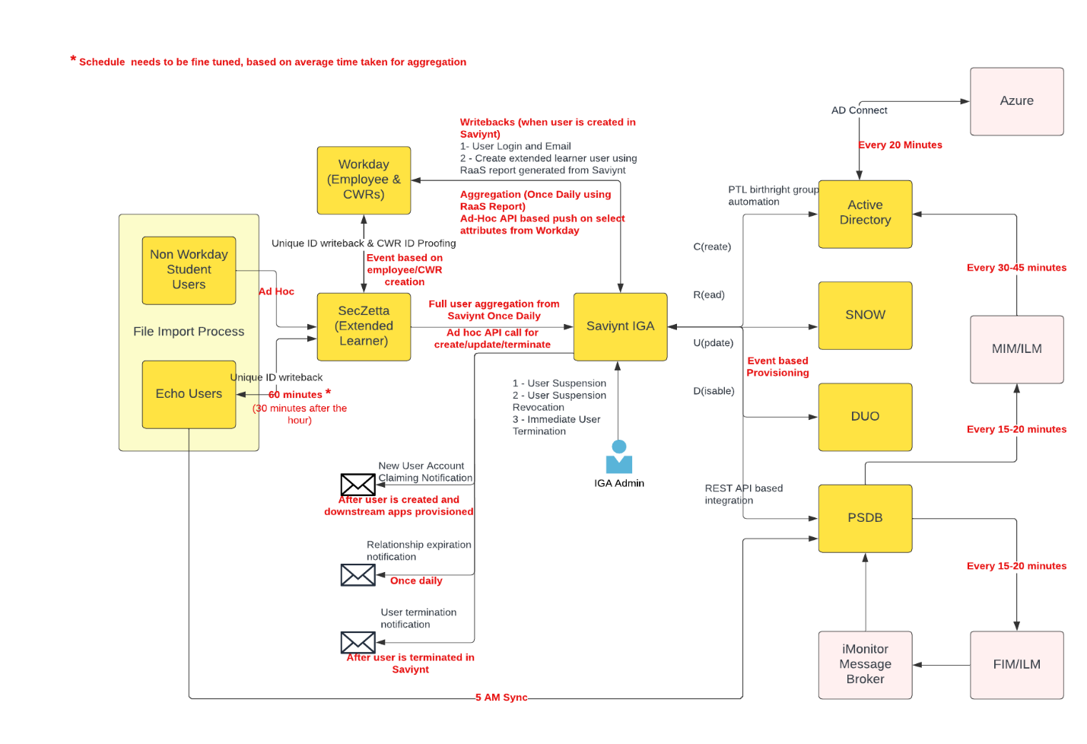
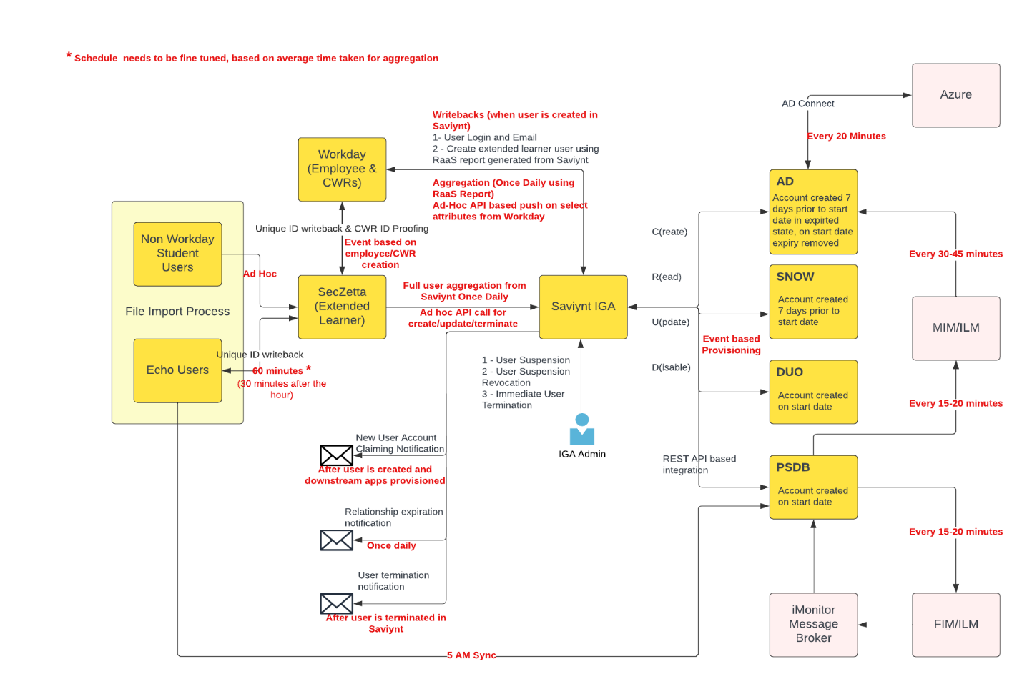
Figure1: High Level Integration Diagram
The above diagram explains the high-level setup for Saviynt IGA implementation at Sentara Healthcare.
Prerequisites for the Integration:
- Infrastructure Setup – setting up environment with required based configuration in Saviynt SaaS.
- Establish IPsec tunnel for on-prem connectivity.
- DNS forwarder setup – To identify corresponding ips for configured hostname (On-Prem application) in Saviynt.
- The Connectivity between Saviynt IGA and Workday / SecZetta / Echo
- The Connectivity between Saviynt IGA and Service Now / Duo
- The Connectivity between Saviynt IGA and PSDB
- The Connectivity between Saviynt IGA and AD should be established.
- Certificates for communication with AD over SSL
- ADFS SSO.
- SMTP mailbox details
- Azure API Setup
- <TBD>`

Detailed Explanation of the Components:
Component Name | Description
Workday | Workday will be the authoritative source of HR data for all employees and Contingent workers.
SecZetta | SecZetta will be the authoritative source for all extended learners.
Echo | Echo will be the authoritative source for all credentialed Provider information
Saviynt IGA | Saviynt Identity Governance and Administration - SAAS based tool to manage identities and automate their access provisioning to the Connected systems.
AD | Birth right target application. Saviynt IGA provides OOTB connector for integration with AD
Service Now (SNOW) | Saviynt IGA provides OOTB REST connector for integration with SNOW
Duo | Birth right target application. Saviynt IGA provides OOTB REST connector for provisioning with Duo and Duo connector for reconciliation
PSDB | MS SQL based application
O365 | Will be managed based on AD groups
Azure API | Azure API end point to clear the active session

Assumptions:
- Data clean-up is the responsibility of the Sentara Healthcare teams for all in-scope systems, service accounts, including orphan and dormant accounts.
- No customizations are required to the Saviynt IGA UI. Only colour schemes, customer logo and Label changes will be in scope.
- Sentara Healthcare technical team will provide the information about process – as is for all in scope connected systems.
- Sentara healthcare will share the test cases, lead and execute all SIT, UAT, QA, DR, performance and security testing cycles.
- Any technical changes made in Saviynt IGA shall be published for the information of all the concerned parties involved.
- QA environment to be maintained as close as possible to PROD.
- Workday will be considered as authoritative sources for all employees and contingent worker including legacy users.
- SecZetta applications will be considered as authoritative sources for all extended learners. If the user exists as an employee in Workday and Extended learner in SecZetta, Unique ID generated from SecZetta must be the same as unique id in Workday and SecZetta will be considered as the authoritative source of such ID.
- AD, Service Now and Duo accounts to be provisioned as birth right.
- All non-prod Saviynt environments must connect with Sentara’s non-prod application environments.
Attributes having Special chars (like first name. last name and other attributes) will be sent to downstream applications.
Pankaj

Architecture Flow: User Onboarding

3.2.1 Workday As An Authoritative Source – Employee Onboarding

Assumptions
● For any user which is present in Workday as well SecZetta, Saviynt expects the user to be reconciled only from a single source and not both.
● Saviynt will reserve one custom property attribute on the user profile to store the source of the user data like ‘Workday’, ‘SecZetta’ etc.
● Workday will provide the users relationships as comma separated values.
● SecZetta and Workday will sync up to update employee/ contingent worker Unique Identifier. This will be outside Saviynt EIC
● All existing employees and contingent workers will have a unique identifier populated when reconciled from an authoritative source.

Design
  - Identify user provisioning start date: Hire date must be a mandatory field for the users being onboarded. Saviynt will read the hire code from workday import and take necessary action.
  - For the future dated scenarios, the provisioning shall be driven based on provisioning/start date (computed in Saviynt) and hire code.
  - For the users with Hire date less than 7 days from current date, the pre-processor logic in workday connection shall be used to populate their provisioning/start date and on update of the same, provisioning rules shall trigger.
  - For the users with Hire date greater than 7 days from current date, the pre-processor logic shall not populate the user data in Saviynt.
  - TBD - Number of RAAS Reports
  - Workday full user sync up
  - Workday daily new hire

Unique Identifier for user Corelation from workday

Workday | Saviynt
Unique Identifier | Username

Figure: High level design of onboarding from workday

Workday – Reconciliation approach
- Workday RaaS report – full user sync-up
  - One RaaS report will be created having all employees and contingent workers.
  - Daily nightly sync up will be scheduled.
  - Future dated hire will be taken care by nightly sync up.
  - Unique Identifier is must for all employees and contingent worker.
  - Extended learners will not be part of this report as SecZetta is source for Extended l learners.
Workday daily new hire report
  - One RaaS report will be created having all new employees and contingent workers.
  - Multiple sync up job will be scheduled.
  - Note: Schedule frequency will be decided based job time consumption and other factors.
  - Unique Identifier is must for all employees and contingent worker.
  - Extended learners will not be part of this report as SecZetta is source for Extended l learners.

- Saviynt API
  - Workday will invoke Saviynt create/update user API for:
    - Terminate user for back dated termination date/immediate termination only.
    - Update key user attributes so downstream applications can be updated for same.
    - LastName
    - FirstName
    - Job ProfileID
    - UDAK
    - Location
    - Manager
    - Mobile Phone
    - Additional CWR add
    - Business Phone

  - API details: https://documenter.getpostman.com/view/1797923/2s83mbojGM#ee3a3f84-7371-4489-9163-34905bcd4692

- Saviynt report - Extended learners
  - Saviynt will create an analytic report having Extended learner data.
  - Workday will consume Saviynt API as needed to refresh Extended Learner data,
List of attributes for Extended learner <TBD>

API details: https://documenter.getpostman.com/view/1797923/2s83mbojGM#90ee72f3-4c52-4866-b016-b234050c333d
Note: Saviynt API will be invoked only for important events where quick processing is required from business perspective.

Workday – Saviynt Attribute Mapping
Refer Appendix

Data pre-processor
Assumptions:
Identify user provisioning start date: Hire date must be a mandatory field for the users being onboarded.
Details | Purpose
Pre-processor at workday RAAS – new hire | - Remove accented characters from the data before updating in Saviynt EIC  - Check Record type = Contingent Worker, then skip to populate the end date for user  - Compute provisioning date based on Management level and the Hire date to decide the user is a future date hire.  - If Hire date > current + 7, import will be skipped.
Pre-processor at workday RAAS – Termination | - Check the relationship value.  - end date is past or current, hire code is “Term”, and status = Inactive to update a flag on the user profile .

Account name Generation
Assumptions:
● All old account names exist in Graveyard OU.
● Saviynt will reconcile the data from Graveyard OU based on a Scheduled Import job.
● Saviynt will store the graveyard accounts in a separate endpoint.
Saviynt will use a utility to develop the logic for calculating the unique system login for account name generation, email address and the email alias for the users.
The utility will check the account names from existing active accounts in AD as well as the account names from graveyard OU.

BASIC LOGIC | Result
if middle name is not present, Use First character of first name, “X”, Last name up to 6 characters so to make the System login not more than 8 chars | e.g. John Smith – JXSMITH  Jacob Smith – JXSMITH1 ………. Upto JXSMITH9  Then, JXSMIT11…. JXSMIT50  Joseph Mor – JXMOR  until unique one is found
if middle name is present, Use First character of first name, first character of middle name, Last name up to 6 characters so to make the System login not more than 8 chars | John Max Smith – JMSMITH  Jacob Mary Smith – JMSMITH1 ………. Up to JMSMITH9  until unique one is found

Email Generation
uniquesystemlogin@sentara.com where unique system login logic is described in the previous section.
Condition | Result
Logic will be same as unique system login | uniquesystemlogin@sentara.com

Email Alias Generation
Assumption:
● Sentara will provide the dump of all existing aliases.
● Saviynt will store these aliases in an endpoint (defined in Saviynt)
Saviynt’s utility logic will read all the existing email aliases from the reconciled data from AD provided by Sentara and develop the logic to find and populate the unique email alias for the new user hires.

Condition | Result
preferredfirstname.lastname@sentara.com  if exists, append with numbers | James.smith@sentara.com  If exists, james.smith1@senatara.com

UTILITY: AccountName, Email and Email Proxy Address Generation
Account name generation Rule.
Provisioning rule name | Event | Condition | Actions
UR: Account Name Generator | New User | If New User Created & Status=Active | Generate Account Name, Email and EmailProxyAddress
UR: Account Name Generator | Update User | If Fname, Lname or Mname is updated & Status=Active | Generate Account Name, Email and EmailProxyAddress
UR: Rehire After 30 Days User Update Rule | Rehire | If user rehire after 30 days | Generate Account Name, Email and EmailProxyAddress

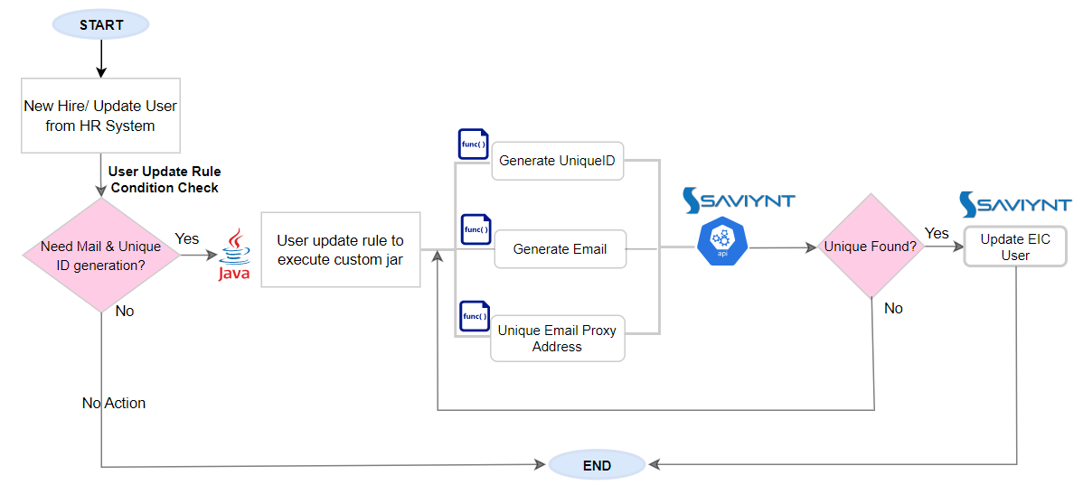

Jobs
Job Type | Schedule
Workday User import job | Daily once in night

SecZetta As An Authoritative Source

Assumptions
- For any user which is present in Workday as well SecZetta, Saviynt expects the user to be reconciled only from a single source and not both.
- SecZetta users will be reconciled on their start date itself. There will not be future dated processing.
- SecZetta will send the end date and manager as mandatory attributes in the feed.
- User’s manager’s manager will not be managed by Saviynt – rather SecZetta should send the correct manager mapping for the user.
- Saviynt will reserve one custom property attribute on the user profile to store the source of the user data like Workday, SecZetta etc.
- SecZetta will provide the relationships as comma separated values.
- All existing Extended Learners will have a unique identifier populated when reconciled from an authoritative source.

Unique Identifier for user Correlation from SecZetta
SecZetta | Saviynt
UniqueIdentifier | Username

SecZetta– Reconciliation approach
- SecZetta API – full user sync-up
  - SecZetta API will be used for full External user sync up.
  - Daily nightly sync up will be scheduled.
  - Unique Identifier is must for Extended Learners.
  - Employee and Contingent worker will not be part of this API call.

- Saviynt API
  - SecZetta will invoke Saviynt create/update user API for:
    - Create new user for immediate new hire with relationship.
    - Update relationships. Possible format (<TBD>) Relationship1: Enddate, Relationship2:Enddate
    - when the relationship has ended - do not send the relationship: enddate. Just send the updated attribute with the existing relationships and its end date.
    - Update key user attributes so downstream applications can be updated for same.
    - FirstName
    - LastName
    - Sponsor
    - Relationship and its end date

Note: Saviynt API will be invoked only for important events where quick processing is required from business perspective.
API details: https://documenter.getpostman.com/view/1797923/2s83mbojGM#ee3a3f84-7371-4489-9163-34905bcd4692
Note: For Credential physician, SecZetta will add 30 days in termination date.

Design Aspects
- Saviynt will receive new Extended Learners’ data from SecZetta for the users on their start date via the REST Connector implementation. Same connection will be used to aggregate the updates for the existing Extended Learner users too.
- Saviynt will generate the unique system login and use Customproperty1 to store the same.

- Attribute mapping.

- Refer Appendix

Data preprocessor
Details | Purpose
<tbd>

Account name Generation
As mentioned above in workday section

Email Generation
Assumption:
- Saviynt will reconcile the extended learner’s personal email id in the Saviynt Email field.
If the personal email address is not populated
Condition | Result
If no email existing | <samaccountname>@fakesentara.com

Reconcile jobs
Name | details | Frequency
SecZetta_User_Import_full | User Import via a Connection which uses REST connection and the attribute mapping to bring new users / updates and termination feed. REST connector imports are only supported in Full mode. | Daily once in night

NEW HIRE

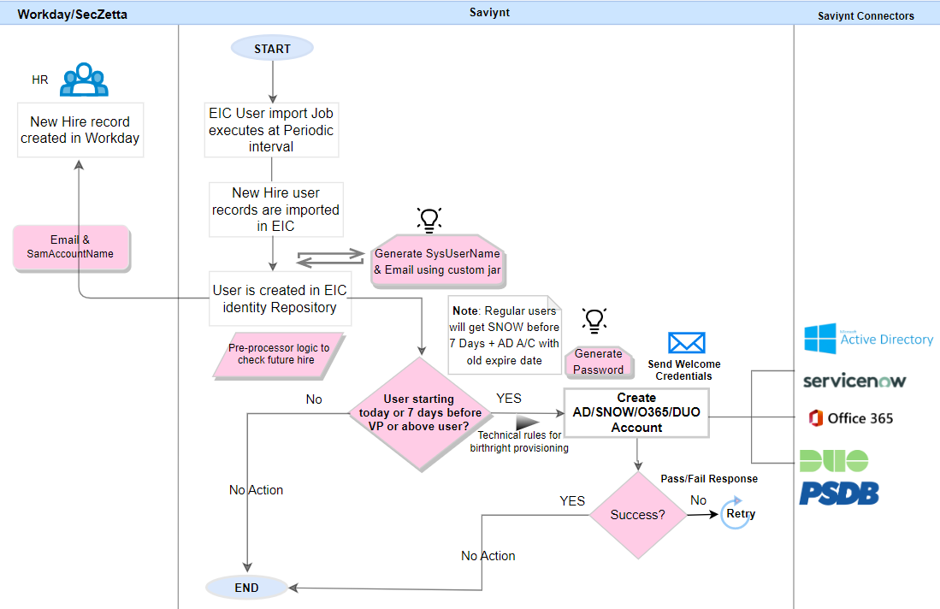

Future dated Hire
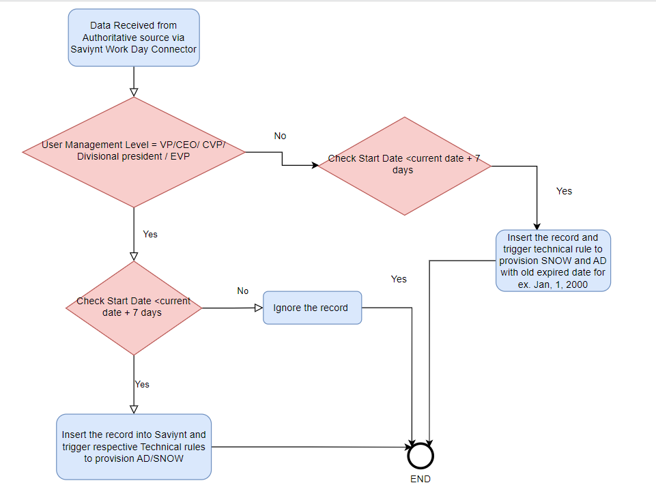

Enterprise role – Workday
Role name | Entitlements
ENTRole_Employee | PTL_Employees, ANYCON_IT, DSG_GLOBAL_SHAREVOL01
ENTRole_NonEmployee | PTL_NonEmployee, ANYCON_IT, DSG_GLOBAL_SHAREVOL01

Provisioning rules for new hire – Workday
Provisioning rule name | Condition | Provisioning target
TR: Birthright Access to VP_and_Above | ManagementLevel in (VP,CEO,CVP, Divisional president , EVP ) | AD, SNOW, DUO, PSDB
TR: Birthright Access to PTL_Groups_Employees | Usertype=employee | Enterprise Role “ENTRole_Employee” to provide access to AD groups PTL_Employees, ANYCON_IT, DSG_GLOBAL_SHAREVOL01
TR: Birthright Access to PTL_Groups_NONEmployees | Usertype = contingent worker | Enterprise Role “ENTRole_NonEmployee” to provide access to AD groups PTL_NonEmployee, ANYCON_IT, DSG_GLOBAL_SHAREVOL01
TR: Birthright Access to E3_License | (Job Category = Registered Nurse AND Job Level = Band 5 Expert)  OR  (Job Category = Allied Health Professional AND Job Family Group = Clinical Nursing)  OR  (Job Category = Clerical-Business Support AND (Job Profile Description not like ‘Student’ OR Job profile!=102350)  OR  (Job Category= Clerical-Patient Support AND Job Family Group in (Corporate ,Health Plan))  OR  (Job Category= Clerical-Patient Support AND (Job Profile Description not in [‘Student’, ‘Intern’, ‘Scheduling Coordinator, Business Support’]  OR Job Family Group in (Corporate, Health Plan)) | SG_O365_E3_ExchangeOnline
TR: Birthright Access to E5_License | Company Reference ID = CM101 AND Reporting Division ID = RD1004  AND Cost Center Reference ID = CC27091004 AND User Type = Employee;  OR  Company Reference ID = CM117  AND Reporting Division ID = RD1004  AND Cost Center Reference ID = CC27091004 AND User Type = Employee; | SG_O365_E5_ExchangeOnline
TR: Birthright Access to F3_License | Not in (Users in TR: Birthright Access to E3_License , Users in TR: Birthright Access to E5_License) | SG_O365_F3_ExchangeOnline
TR: Birthright Rule to Grant Persona Based Access | If User.Cprelationship contains (Persona1) OR  If User.Cprelationship contains (Persona2) OR  If User.Cprelationship contains (Persona3) OR  ….so on | Refer Persona based User management
UR: Generate Unique System Login and Email | Systemusername is not null (unique identifier is present for the user) | Trigger when user is created via import and call the custom jar code
UR: Notify IAM_Operations_UniqueID_missing | Systemusername is null (unique identifier is not present for the user) | Trigger when user created via import and call the notify via email method

Enterprise role – Based on SECZETTA
Role name | Entitlements
ENTRole_Physician | Community Connect Physician | PTL_PHYSICIAN
ENTRole_Community_Physician | Community Physician | PTL_PHYSICIAN
ENTRole_CEMR Clinical staff | CEMR Clinical staff | PTL_MD_STAFF
 |  | PTL_MD_STAFF_CLNICAL
ENTRole_ Community_Clinical staff | Community Clinical staff | PTL_MD_STAFF
 |  | PTL_MD_STAFF_CLNICAL
ENTRole_EVMS_Medical Student | Student – via MDOffice | PTL_MD_STAFF
 |  | PTL_MD_STAFF_CLNICAL
ENTRole_EVMS_Resident | Resident – via MDOffice | PTL_PHYSICIAN
ENTRole_OHP Broker | OHP Broker | PTL_OHW_BROKER
ENTRole_VAP Broker | VAP Broker | PTL_VPHP_BROKER
ENTRole_Benefits Administrators | Benefits Administrators | PTL_OHW_BRM
ENTRole_OHW Provider | OHW Provider | PTL_PHYSICIAN
 |  | PTL_MD_STAFF_CLINICAL
 |  | PTL_MD_STAFF
 |  | PTL_OHW_PHYSICIANS
 |  | PTL_SBHS_PHYSICIAN
ENTRole_OHW Staff | OHW Staff | PTL_MD_STAFF
 |  | PTL_MD_STAFF_CLNICAL

Provisioning rules for new hire- SecZetta
Provisioning rule name | Condition | Provisioning target
TR: Birthright Access_Extended Learners | Employee type= Extended Learner and statuskey=1 | AD,SNOW,DUO,PSDB
TR: Birthright Rule to Grant Persona Based Access | If User.Cprelationship contains (Persona1) OR  If User.Cprelationship contains (Persona2) OR  If User.Cprelationship contains (Persona3) OR  ….so on | Refer Persona based User management

User update

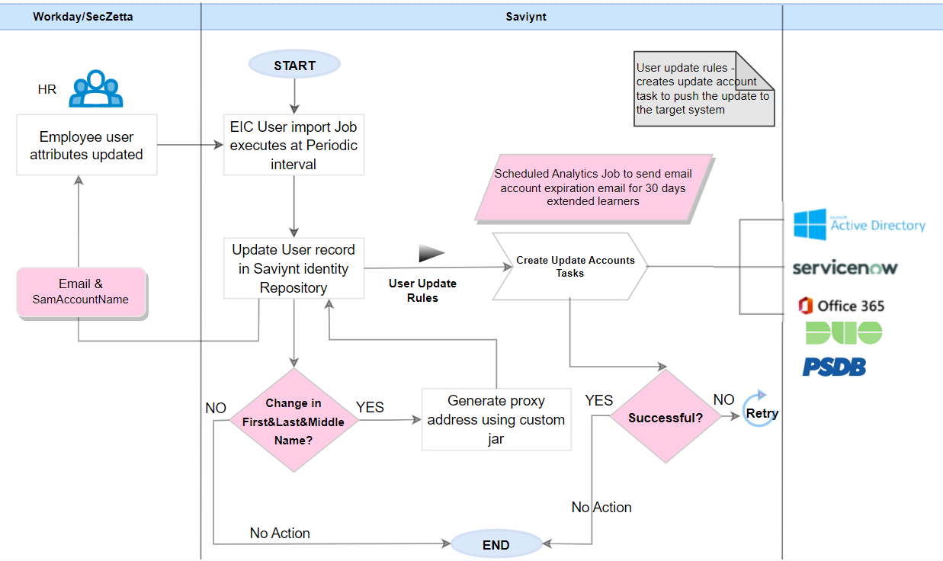
Saviynt will reconcile the updates from workday for employees and workers using the User import job as mentioned in New hire section.

Provisioning rules for user update
Provisioning rule name | Condition | Provisioning target | Event Trigger
UR:Update_Accounts | Consider TBD attributes that need to be updated in various target applications | AD,SNOW,DUO,PSDB | Trigger when Updated via import
UR: Retrigger Technical Rules for Persona | CP_{relationship} is updated | Re-run technical rules for the Enterprise role assignment | Trigger when Updated via import

Termination

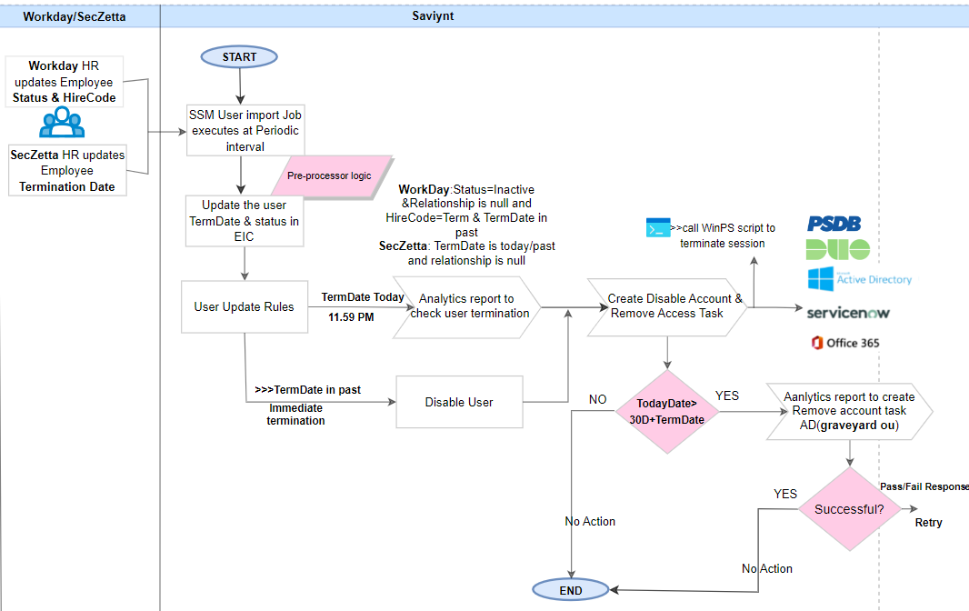

Provisioning rules for Termination
Provisioning rule name | Condition | Provisioning target | Event Trigger
UR:Termination_Workday | Statuskey=0 and CP_{relationship} is null/blank or cost center =25341900 | create tasks to disable and deprovision AD,SNOW,DUO,PSDB | Trigger when Updated via import
UR:Termination_ExtendedLearner | TermDate <= Today’s date and CPreletioshipel is null or blank | create tasks to disable and deprovision AD,SNOW,DUO,PSDB | Trigger when Updated via import or api

UR: Emergency Termination – one click | Username is not null | Creates tasks to disable and deprovision AD,SNOW,DUO,PSDB  Clear session using Azure API connection | Trigger when user removed via one click disable

Persona based User management
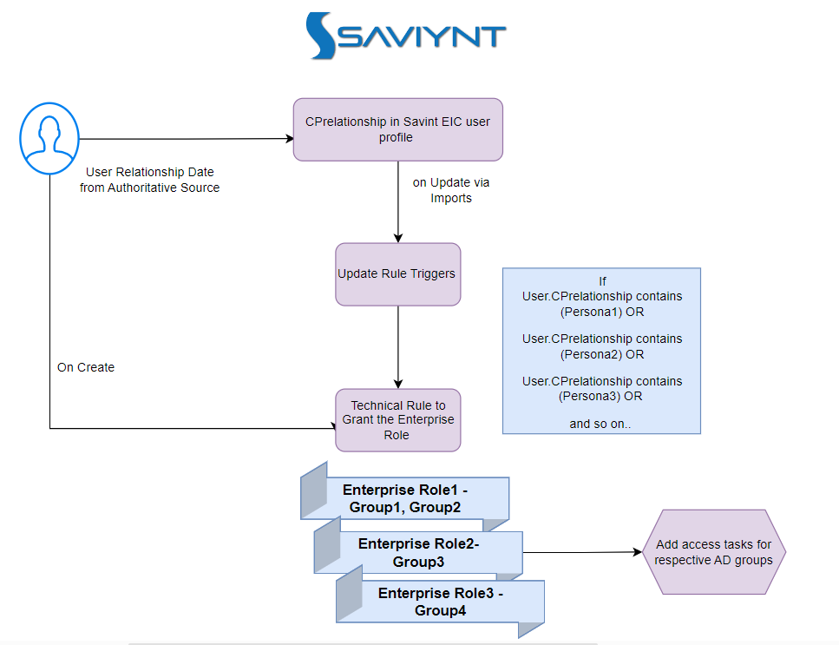

- Sentara Healthcare’s environment involves establishing multiple relationship models, so that a user identity at any given time can have multiple roles in an organization.
- Saviynt can handle this requirement by creating Enterprise roles for different personas and encapsulate relevant entitlements( AD Groups) under it for easy management when the personas change.
- Saviynt can consume the user relationships in a custom property. Assumption for the format of the CP from the authoritative source is comma separated as below, For instance,
CP_{relationship} = Student, Clinical Physician, Broker
- Each role/relationship will have a corresponding Enterprise Role with the same name, for instance –
ER1= Student – AD groups 1 and 2
ER2= Physician – AD group 3
ER3= Broker – AD group 4
- If no relationship is received in the update feed, all Roles will be removed.
- Termination on end date will not be processed: if status = Active and end date is current Date and CPxx contains one or more values.
- If the end date is reached and user CP_{relationship} is received without an active relationship value in the CP, the actionable analytics will pick up the user to be terminated and create Disable user tasks.
- Subject to POC: Saviynt will trigger email notifications to identified user groups (relationship owner group) 30/14/7 days prior to the user’s end date. Saviynt will use an Analytics engine for this.
- Saviynt will evaluate the option to generate the notification based on data format shared by SecZetta as each relationship has its own expiry date which is adding complexity.
- As option 2, SecZetta can generate these notifications as it’s a quick configuration in SecZetta, once Saviynt identify the option it can be rolled to Saviynt.
- The Relationship Owner group will be maintained by the Sentara Healthcare IAM team.

Enterprise role based on persona
Role name | Persona | Entitlements
ENTRole_Physician | Community Connect Physician | PTL_PHYSICIAN
ENTRole_Community_Physician | Community Physician | PTL_PHYSICIAN
ENTRole_CEMR Clinical staff | CEMR Clinical staff | PTL_MD_STAFF
 |  | PTL_MD_STAFF_CLNICAL
ENTRole_ Community_Clinical staff | Community Clinical staff | PTL_MD_STAFF
 |  | PTL_MD_STAFF_CLNICAL
ENTRole_NonWDStudent | Student – via MDOffice | PTL_MD_STAFF
 |  | PTL_MD_STAFF_CLNICAL
ENTRole_OHP Broker | OHP Broker | PTL_OHW_BROKER
ENTRole_VAP Broker | VAP Broker | PTL_VPHP_BROKER
ENTRole_Benefits Administrators | Benefits Administrators | PTL_OHW_BRM
ENTRole_OHW Provider | OHW Provider | PTL_PHYSICIAN
 |  | PTL_MD_STAFF_CLINICAL
 |  | PTL_MD_STAFF
 |  | PTL_OHW_PHYSICIANS
 |  | PTL_SBHS_PHYSICIAN
ENTRole_OHW Staff | OHW Staff | PTL_MD_STAFF
 |  | PTL_MD_STAFF_CLNICAL

Provisioning rules for Persona Based access
Provisioning rule name | Condition | Provisioning target
TR: Birthright Rule to Grant Persona Based Access | If User.Cprelationship contains (Persona1) OR  If User.Cprelationship contains (Persona2) OR  If User.Cprelationship contains (Persona3) OR  ….so on | Grant enterprise role with underlying roles.

Architecture Flow: User Rehire

Assumptions:
              - Authoritative source Workday to send below data for a user to be considered a rehire:
- Hire code = “Rehire”
- Employee status as Active
- extended end date ( past end date is within 30 days of current date)
- A valid relationship value in CP_{relationship} (if needed)
  - New system login to be created by IAM if rehired after 30 days of termination.

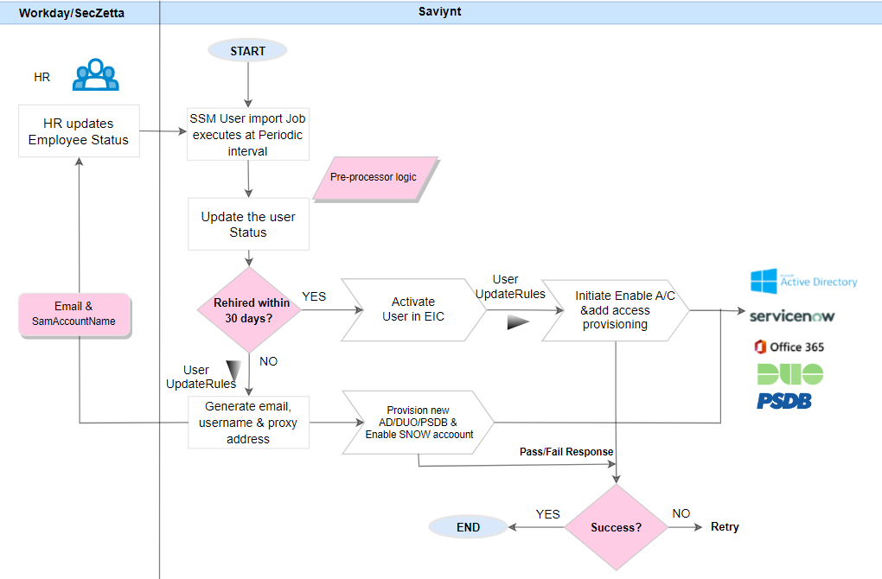

Figure: Flow diagram depicting the rehire process for users in Saviynt.

- Saviynt will receive the rehire feed from the authoritative source with the proper hire code, status code to denote Active status.
- Saviynt Engine will identify the user already exists based on the unique identifier and trigger user update Rules to update the user accounts which are in inactive status –
- On rehire , the new system login (samaccount name and email will be provisioned to the OU=ADO, OU=USER, DC=Corp, DC=ad, DC=Sentara, DC=com in AD.

Provisioning rules for Rehire
Provisioning rule name | Condition | Provisioning target | Trigger Point
UR: Rehire_Workday_On_Import | hire code = Rehire, statuskey=1 | AD/Duo/SNOW/PSDB | trigger when updated via Import
UR : Rehire_SecZetta_On_Import | statuskey=1 | AD/Duo/SNOW/PSDB | trigger when updated via Import

User Suspension & Revoke Suspension

Assumptions:
- Users will be active. Only AD and DUO accounts will get suspended using the suspend option Users will come as active from HR sources.
- All assigned groups will be removed.

Provisioning Rule Names

Provisioning rule name | Condition | Provisioning target | Event Trigger
UR: Suspension_By_Admin | CP_{suspension} is updated by Admin to value ‘Suspend’ | Creates tasks to expire AD, , disable DUO,  Clear user Azure session using Azure API connector | Trigger when Updated via UI
UR: Revoke_Suspension_By_Admin | CP_{suspension} is updated by Admin to blank/empty value | Creates tasks to remove expiry date from AD, ,enable DUO, and rerun technical rules | Trigger when Updated via UI

User Suspension:
- Admin can login to Saviynt, and update defined Custom Property Attribute to ‘Suspend’
- Once CPx is updated, Saviynt will trigger the corresponding user update rule to take the following actions: refer the below

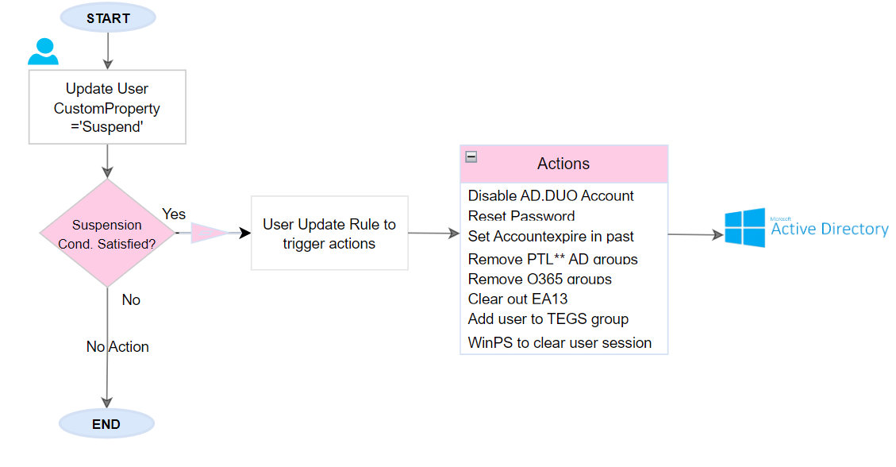
Revoke Suspension:
- Admin can login to Saviynt and clear the defined custom property.
- Once CPx is updated, Saviynt will trigger the corresponding user update rule to take the actions: refer to below figure

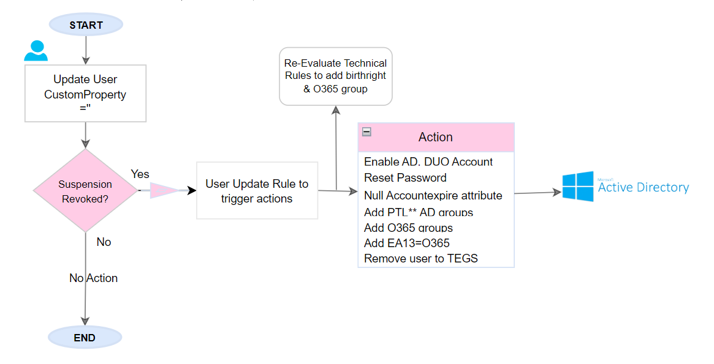

Immediate Termination

Assumptions:
- With immediate termination, users will get disabled into the EIC identity repository and all accounts/groups will get revoked.
- The HR team will take care to disable the user in the HR system.
- Customer will provide PowerShell scripts and grant required permissions to revoke azure session.

Provisioning Rule Names

Provisioning rule name | Condition | Provisioning target | Event Trigger
UR: Emergency Termination | Username is not null | Creates tasks to disable and deprovision AD,SNOW,DUO,PSDB | Trigger when user removed via one click disable

Immediate Termination
- This functionality will be enabled for Admin users.
- Admin can login and select the “One Click Disable” tile on the home page to terminate any given identity immediately.
- On successful request submission, users will get disabled in EIC and all downstream application access will get removed.
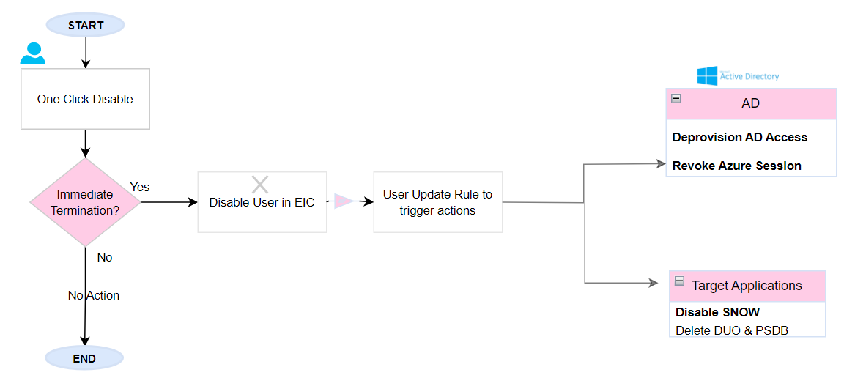

Revoke user azure session
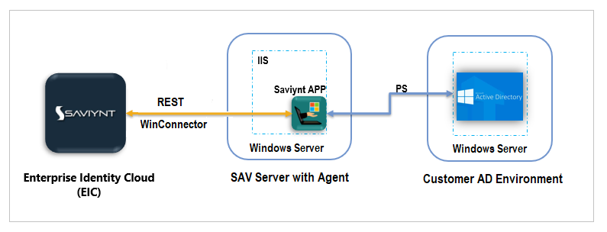
  - Saviynt will use its Windows PowerShell connector to execute or call the PowerShell scripts to revoke Azure sessions.
  - This will be achieved by creating a separate endpoint which will use AD connection for reconciliation and windows PowerShell connector for the provisioning actions.

Active Directory Provisioning

Saviynt will support the provisioning, aggregation, and correlation of users for Active Directory applications. Saviynt IGA will utilize an AD OOTB connector for handling the provisioning to AD.

10.1 Assumptions:
- Sentara will update the unique identifier for all existing accounts.
- Saviynt will import all the users from Graveyard OU for unique SamAccountName generation

10.2 Prerequisites:
- Service Account details for AD connection
- AD Domain certificate for AD connectivity over SSL
- Successful Connectivity from Saviynt to AD via Ipsec tunnel
- Password Policy
- OU details for provisioning and reconciliation
- Attribute Mapping details

10.3 Connection Design
Saviynt will use the OOTB AD connector to integrate with the AD application.
The integration flow of AD with Saviynt involves.
- EIC will import the user information at periodic intervals from the HR source.
- EIC creates/updates user records received from HR in the identity repository.
- EIC will execute the Create/Update/Delete accounts and groups provisioning.
- EIC will generate the new random password during account creation and will notify the user manager.
- EIC will store all the event information for audit purposes.
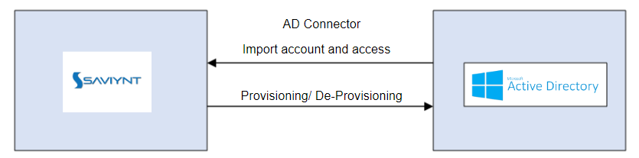

10.4 Saviynt-AD Import Attribute Mapping
Refer Appendix

10.5 AD Account Management Processes
This section describes the account lifecycle process flow for AD application.

Important Rules

Rule name | Condition | Format
User correlation rule | CPx=samAccountName | -
Account Name Rule | SamAccountName | As explained in uniquename generation
DN | DN | CN=samAccountName,OU=ADO/BA_Brokers,OU=USER, DC=Corp, DC=ad, DC=Sentara, DC=com

User Events

Event | COndition | Action
Import User | - Import Account OU: OU=USER, DC=Corp, DC=ad, DC=Sentara, DC=com  - Group Import OU: ? TBD  - Import Users From GraveYard OU | samAccountName is unique ID:  If match found Co-relate else create new account
New Hire | If ((user is benefit admin & broker & CP has emp relationship) OR (user is not benefit admin & broker) | Provision to OU=ADO
New Hire | IF(user is benefit admin & broker)  7 days in advance  On hire date | Provision to OU=BA_Brokers  Set expiration date in past in addition to other access  Remove expiration date
Update User | IF(Any map user attribute updated) | Provision updates in AD
 | IF(Any birth right access associated attribute updated) | Re-evaluate birth right rules and provision required access
Termination | User is disabled/status changes to inactive | Disable AD account (514) & for employee & Contingent Worker
Termination | User is disabled/status changes to inactive | Send termination email to supervisor
Termination | 30 days passed after termination | Move User to Graveyard OU and Revoke Azure Session
Rehire | Rehired within 30 days of termination | Enable AD account & evaluate birthright rules
 | Rehired after 30 days of termination | Create new AD account and evaluate birthright rules

ServiceNow Provisioning
Below This section describes the high-level design for the Saviynt EIC integration with ServiceNow. ServiceNow is the birth right application for all users.

11.1 Assumptions:
- Each existing account will have “unique identifier” associated which will match with workday user’s “unique identifier” (Generated via Seczetta).
- Orphan accounts will be mapped by customer.

11.2 Prerequisite:
- Service Account details
- Connectivity from Saviynt to ServiceNow
- Attribute Mapping details

11.3 Connection Design
Saviynt will use the REST connector to integrate with the ServiceNow application.
The integration flow of ServiceNow with Saviynt involves
- EIC will import the user information at periodic intervals from the HR source.
- EIC creates/updates user records received from HR in the identity repository.
- EIC will provision Create/Update/Disable/Enable to SNOW.
- EIC will store all the event information for audit purposes.
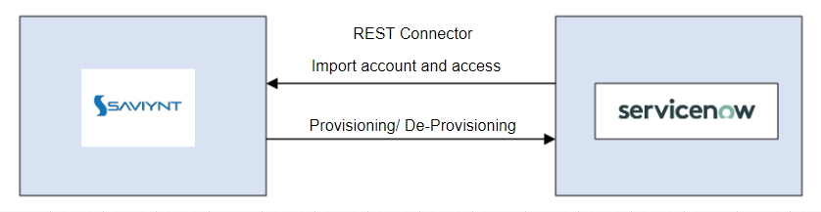

11.4 Saviynt-ServiceNow Attribute Mapping
Refer Appendix

11.5 ServiceNow Account Management Processes
This section describes the account lifecycle process flow for ServiceNow application.

Important Rules
Provisioning rule name | Condition
User correlation rule | Account.UniqueIdentifier = User. UniqueIdentifier
Account Name Rule | Account name generated via utility

User Events
Event | Condition | Action
Import User | Import accounts from SNOW | If match found Co-relate else create new account
New Hire | New User Created | Provision SNOW Account
Update User | IF(Any map user attribute updated) | Provision attribute updates to SNOW
 | IF(Any birthright access associated attribute updated) | Provision account
Termination | User is disabled | Disable SNOW Account
Rehire | Rehired within 30 days of termination | Enable SNOW and provision & evaluate birthright rules
 | Rehired after 30 days of termination | Enable SNOW & send update for SystemLogin & email Attribute. Evaluate birthright rules

Duo INTEGRATION (FULL)
Saviynt will support the provisioning, aggregation, and correlation of users from DUO. Saviynt IGA will utilize a REST based integration approach for handling the provisioning to DUO. Extending the DUO integration for reconciliation of Accounts and Access

13.1 Assumptions:
- Each existing account will have “unique identifier” associated which will match with user’s “unique identifier” in the system of record.
- Orphan accounts will be mapped by the customer.
- Sync between Active Directory and DUO will be stopped

23.2 Prerequisite:
- Service Account details
- Connectivity from Saviynt to Duo
- Attribute Mapping details
- Sync between DUO and Active Directory is turned off
- DUO groups details and criteria to add them to users has been provided.

13.3 Connection Design
Saviynt will use the REST connector to integrate with the Duo application.
The integration flow of Duo with Saviynt involves
- EIC will import the user information at periodic intervals from the HR source.
- EIC creates/updates user records received from HR in the identity repository.
- EIC will create/update/disable/enable the DUO account.
- EIC will send the account claiming email to the end-user with instructions to register the device within Duo.
- EIC will store all the event information for audit purposes.
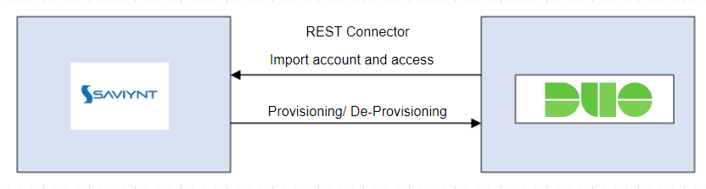

13.4 Saviynt-Duo Attribute Mapping
Reconciliation
Saviynt Account Attribute | DUO Attribute
accountID | user_id
Name | Username
displayname | C
Customproperty4 | Email
Customproperty6 | last_login
Customproperty7 | Notes
Customproperty9 | Realname
Customproperty14 | Status
Customproperty14 | Phonenumber(number)

Provisioning
Refer appendix

13.5 DUO Account and access Management Processes
This section describes the account lifecycle process flow for Duo application. Currently DUO account is created along with Active Directory Groups associated with DUO. DUO syncs these groups from Corp AD. This configuration will be removed from Saviynt Configuration to assign the Corp AD DUO groups. Duo Account will be provisioned along with DUO access group as part of birthright Access.
Reconcile Phone number
AS Part of phase-2, phone number attribute is reconciled into Saviynt by mapping the Account import attribute Check the Appendix for mapping.
CUSTOMQUERY JOB
DUO account mobile phone number attribute will be used for provisioning into SNOW. Once the DUO reconciliation is completed, Additional CustomQuery job is configured to copy the value of the mobile phone number attribute into user profile attribute (Into one of the custom property)
Select a.cp4 as u.cpX,u.userkey as user_primarykey from user u,accounts a,user_accounts ua where u.userkey=ua.userkey and ua.accountkey=a.accountkey and a.endpointkey=<TBD>

Important Rules
Provisioning rule name | Condition
User correlation rule | Account.UniqueIdentifier = User. UniqueIdentifier
Account Name Rule | Account name generated via utility(User.Systemusername)

User Events
Event | COndition | Action
Import User | Import accounts from DUO | If match found Co-relate else create new account
Import Access | Import Access (groups and applications) from DUO | Imports the Groups
New Hire | New User Created and assign the birth right groups access internal to DUO | Provision DUO account along with with Access single group )
New Hire | New User Created | Email will be sent to with steps to register account in DUO
Update User | IF (Any map user attribute updated) | Provision attribute updates to DUO
 | IF (Any birth right access associated attribute updated) | Re-evaluate birth right rules and provision required access
Termination | User is disabled | Disable DUO Account
 | 30 days passed after 30 terminations | Delete DUO account
Rehire | Rehired within 30 days of termination | Enable DUO and provision.
 | Rehired after 30 days of termination | Create DUO & send updates for System Login & email Attribute.
Suspension | Admin update user’s suspension flag in Saviynt | Disable DUO Account
Suspension Revoke | Admin remove user’s suspension flag in Saviynt | Enable DUO and provision.
Assign Access for new hire | As part of Birth right Access will be assigned for new hire | AddAccess and provision
Remove Access | IF (Any birth right access associated attribute updated) | Remove Access And deprovsion

PSDB Provisioning
Saviynt IGA will utilize a Rest API based integration approach for handling the provisioning to Portal databases such as PSDB and associated databases. PSDB stores demographic information such as a person's home address, date of birth and gender. Corporate Portal holds all person job related attributes and data.

14.1 Assumptions:
- PSDB team will provide store procedures for all provisioning actions:
  - New Hire
  - Termination
  - Update
  - Rehire
- PSDB team will provide API t to import accounts and entitlements (if required).
- Account details for reconciliation:
- Unique Identifier
- First Name
- Last Name
- Status
- Relationships

- Each existing account will have “unique identifier” associated which will match with workday user’s “unique identifier”.
- Orphan accounts will be mapped by the customer.

14.2 Prerequisite:
- API connection details
- Connectivity from Saviynt to PSDB
- Attribute Mapping details

14.3 Connection Design
Saviynt will use the Workday Load API using Saviynt REST connector to integrate with the PSDB application.
The integration flow of Workday Load API with Saviynt involves.
- EIC will import the user information at periodic intervals from the HR source.
- EIC creates/updates user records received from HR in the identity repository.
- EIC will initiate the birth right for PSDB accounts using technical rules.
- EIC will be configured to trigger PSDB account provisioning using API for create/update/enable/disable operations.
- EIC will store all the event information for audit purposes.

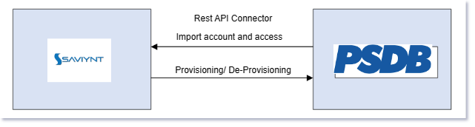

14.4 Saviynt-PSDB Import Attribute Mapping
Refer appendix

14.5 PSDB Account Management Processes
This section describes the account lifecycle process flow for PSDB applications.

Important Rules

Provisioning rule name | Condition
User correlation rule | Account.UniqueIdentifier = User. UniqueIdentifier
Account Name Rule | Account name generated via utilty

User Events

Event | Condition | Action
Import Accounts | Import accounts from PSDB | If match found Co-relate else create new account
New Hire | Account Request | Provision user to PSDB
New Hire | Optima Physician | Send attribute update as Physician Office Staff
Update User | IF(Any map user attribute updated) | Provision attribute updates to PSDB
 | Relationship expiration is set to expire after 30 days | Notify Relationship group owner
Termination | User is disabled | Disable PSDB Account
 | 30 days passed after termination | Delete PSDB Account and clear EA13
Rehire | Rehired within 30 days of termination | Enable PSDB
 | Rehired after 30 days of termination | Create PSDB account & send update for SystemLogin & email Attribute.

- SNOW Additional integration
.

15.1 Assumptions:
- Each existing account will have “unique identifier” associated which will match with users “unique identifier” (Generated via TPAG/Saviynt).
- Saviynt will only provision mobile numbers to the new users that are onboarded in Saviynt from Workday
- Saviynt will also update mobile numbers if any of the already existing phone numbers in Saviynt is updated as part of DUO user import process.
- Mobile number for all existing users will be loaded into Saviynt in custom property.

15.2 Prerequisite:
- Service Account details
- Connectivity from Saviynt to ServiceNow
- Attribute Mapping details
  - mobile_number field to be used to provision mobile phone numbers in Service Now

15.3 Connection Design
Saviynt will use the REST connector to integrate with the ServiceNow application.
The integration flow of ServiceNow with Saviynt for mobile number involves
- EIC will import the mobile phone information at Daily importrom DUO into a account custom property <TBD> and then this attribute value is copied into user profile attribute. See DUO integration.
- EIC will use the createAccountJSON and modifyAccountJSON to provision the mobile number from EIC to Service Now
- EIC will store all the event information for audit purposes.

15.4 Saviynt-ServiceNow Attribute Mapping
\"mobile_number\":\"${if(user.customproperty<TBD> != null) {user.customproperty<TBD>} else {''}}\"

15.5 ServiceNow Account Management Processes
This section describes the account lifecycle process flow for ServiceNow application.

Important Rules
Provisioning rule name | Condition
User correlation rule | Account.UniqueIdentifier = User. UniqueIdentifier
Account Name Rule | Account name generated via utility

User Events
Event | Condition | Action
Import User | Import accounts from SNOW | If match found Co-relate else create new account
New Hire | New User Created | Provision SNOW Account with mobile phone if it is present at the time of new user creation
Update User | IF(Any map user attribute updated) | Provision attribute updates to SNOW with mobile phone if it is present at the time of user modification
 | IF(Any birthright access associated attribute updated) | Provision account
Termination | User is disabled | Disable SNOW Account
Rehire | Rehired within 30 days of termination | Enable SNOW and provision & evaluate birthright rules
 | Rehired after 30 days of termination | Enable SNOW & send update for SystemLogin & email Attribute. Evaluate birthright rules

- AD RBAC Additional Provisioning
Saviynt IGA will utilize the out of the box Active Directory connector to extend the AD group provisioning to role-based criteria that will be configured/defined in Saviynt. As soon as the user is created in Saviynt, user update rule will be invoked and user will be added to the appropriate AD groups.

16.1 Assumptions:
- All the AD groups (Security and Distribution) will be imported into Saviynt EIC
- Existing criteria group logic will be shared with CDW team.
- Three files are provided by the Active Directory team which will be used for the analysis for creating the configuration in Saviynt.
- Single Criteria Group – total 5180 entries
- This is provided in .xls or csv format.
- Sentara/CDW team to normalize the single criteria groups to a more robust for example combine all the job code in an OR condition that will give out security group Revenue_Cycle_Team
- Multiple Criteria Group – total 354 entries
- Criteria attributes are AD based and Sentara/CDW team needs to convert that to Saviynt specific attributes.
- This is provided as TXT file.
- Effort will be needed to convert this into .xls or csv format.

16.2 Prerequisite:
- Service Account details for Active Directory
- Connectivity from Saviynt to Active Directory
- Criteria group details from Active Directory team

16.3 Connection Design
Saviynt will use the already existing Active Directory connector and will create user update rules as per the criteria defined in the format defined by the Saviynt team. User update rules will be configured in a csv/xls format and then imported into Saviynt, a sample file can be found here
- SIEM Integration
SIEM (Security Information and Event Management) is a key part of the overall security framework of organizations. It is essential to feed the required security information from enterprise applications into SIEM to monitor and manage security events across the enterprise. Saviynt Enterprise Identity Cloud (EIC) generates audit logs that record all actions performed by a user such as changes to SAV roles, global configurations, and connections. These audit logs include the following entries: OBJECT TYPE, OBJECT NAME, ACTION, ATTRIBUTE, ACCESS BY, ACCESS TIME, IP ADDRESS, and MESSAGE. Exabeam can ingest the logs by using the fetchRuntimeControlsDataV2 API. If you are creating non Elasticsearch-based analytics records, you can ingest the logs into your SIEM solution by using the fetchRuntimeControlsDataAPI.

17.1 Assumptions:
- IAM System will generate and store User/API activity in audit logs.
- Exabeam will read the logs from the REST end point provided by Saviynt EIC and will build the essential logic to consume and process the logs.
- Log aggregated from Saviynt EIC will be normalized by Exabeam.

17.2 Prerequisite:
- Service Account details from Saviynt
- Add SAV_ROLE in Saviynt EIC to the service account to access audit logs
- New runtime analytics control (V2) using an SQL query is created in Saviynt EIC

17.3 Connection Design
Option 1: REST-based integration
In a REST-based integration, the following actions occur:
- User/API activity generates and stores the audit logs.
- The SIEM application makes a REST API call to directly obtain the audit logs.
Option 2: Non-REST-based integration
In a non-REST-based integration, the following actions occur:
- User/API activity generates and stores the audit logs.
- The SIEM agent, an out-of-the-box event connector, a custom script, or an automation script makes a REST API call to obtain the audit logs.
- The SIEM agent, connector, or script normalizes the data and sends it for processing.
Configurations in Saviynt EIC
- The following SQL query will be used to create the runtime analytics control Audit_Logs_Aggregation.
select ua.TYPEOFACCESS as 'Object Type',ua.ActionType as 'Action Taken',u.username as 'Accessed By', ua.IPADDRESS as 'IP Address',ua.ACCESSTIME as 'Event Time',ua.DETAIL as 'Message' from users u , userlogin_access ua, userlogins l where l.loginkey = ua.LOGINKEY and l.USERKEY = u.userkey and ua.AccessTime >= (NOW() - INTERVAL ${timeFrame} Minute) and ua.Detail is not NULL
- Create a dedicated user SIEM_EXABEAM with least privileges required to call the Saviynt fetchRuntimeControlsDataV2 API to obtain the audit logs.
- Password for the user SIEM_ EXABEAM will be reset.
- SAV Role ROLE_SIEM will be created.
- Following permission will be added to ROLE_SIEM
  - Assign the permission to access the web service URL of the Saviynt fetchRuntimeControlsDataV2 API.
  - Assign the permission to verify the analytics record that you created.
- Add ROLE_SIEM Sav role to user SIEM_ EXABEAM
- Exabeam will need to do the following configuration to call the REST API end point created
  - Invoke the authentication API to obtain the authorization token to make a REST API call.
    - Method: POST
    - Endpoint: {{url}}/ECM/api/login
  - Syntax used in the API URLs:
    - {{url}}/ECM/{{path}}/apiName
  - Body:
    - {"username":"admin","password":"password"}
- Invoke the fetchRuntimeControlsDataV2 API to fetch data.
  - Method: POST
  - Endpoint: {{url}}/ECM/{{path}}/fetchRuntimeControlsDataV2
  - Body:
  - {"analyticsname": Audit_Logs_Aggregation ","attributes": {"timeFrame": "<INTERVAL in minutes>"}}

PAM Integration with BeyondTrust
Saviynt will support the provisioning, aggregation, and correlation of privileged users for Active Directory applications. Saviynt IGA will utilize an AD OOTB connector for handling the provisioning of privileged accounts to AD. Saviynt will also use the OOTB BeyondTrust connector to reconcile the privileged accounts from Beyond Trust so that users can be purged/deleted at the time of user termination.

18.1 Assumptions:
- Sentara will update the unique identifier for all existing privileged accounts in BeyondTrust.
- Sentara will update the unique identifiers for all existing privileged accounts in Active Directory.
- Sentara will clean up any orphan privilege accounts so that privilege account in Active Directory matches with BeyondTrust.
- Smart Rules are configured in BeyondTrust to sync users from Active Directory to BeyondTrust
- Criteria will be defined in Saviynt EIC to automatically identify users who are eligible for privilege account

18.2 Prerequisites:
- Service Account details for AD connection for privileged user management
- AD Domain certificate for AD connectivity over SSL
- Successful Connectivity from Saviynt to AD via IPsec tunnel
- Password Policy for privileged accounts
- OU details for provisioning and reconciliation for privileged accounts
- Attribute Mapping details for privileged accounts
- Service account details for Beyond Trust to reconcile and delete PAM accounts in Beyond Trust

18.3 Connection Design
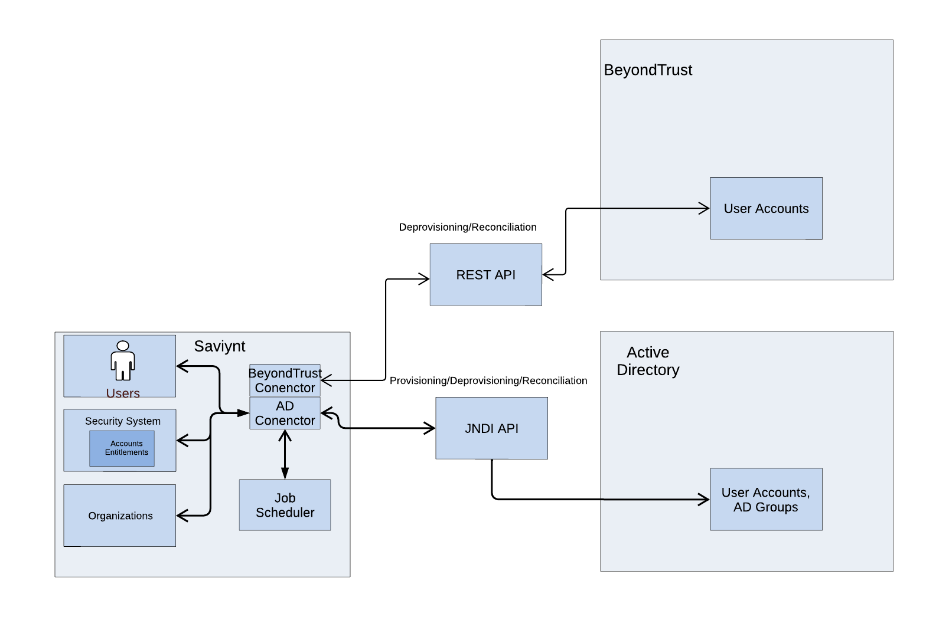
Saviynt will use the OOTB AD connector to integrate with the AD application to provision privileged accounts. Saviynt will also use OOTB BeyondTrust connector to reconcile user accounts and delete them when the user account is terminated in the authoritative source system.
The integration flow of AD with Saviynt involves.
- EIC will import the user information at periodic intervals from the HR source.
- EIC creates/updates user records received from HR in the identity repository.
- EIC will execute the Create/Update/Delete accounts and groups provisioning for the privileged accounts based on the RBAC configurations for all IT user, all privileged accounts will be suffixed with _PBD.
- EIC will generate the new random password during privileged account creation and will notify the user manager.
- EIC will store all the event information for audit purposes.
- EIC will not enable the user provision operation to BeyondTrust connection.
- EIC will configure the account import from BeyondTrust into Saviynt.
- EIC will configure the delete operation as soon as the user with privileged account is terminated in the authoritative source system.

18.4 Saviynt-AD Import Attribute Mapping
Refer Appendix

18.5 AD Account Management Processes
This section describes the account lifecycle process flow for AD application for privileged accounts.

Important Rules

Rule name | Condition | Format
User correlation rule | CPx(systemusername_PBD)=samAccountName | -
Account Name Rule | SamAccountName_PBD | As explained in uniquename generation
DN | DN | CN=samAccountName_PBD, OU=PBPS,OU=ADMIN IDS,OU=User,DC=Corp,DC=ad,DC=sentara,DC=com

User Events

Event | COndition | Action
Import User | - Import Account OU: OU=<TBD>, DC=Corp, DC=ad, DC=Sentara, DC=com  - Group Import OU: DC=Corp, DC=ad, DC=Sentara, DC=com | samAccountName is unique ID:  If match found Co-relate else create new account
New Hire | If ((user is satisfies criteria to have a privileged account according to the technical configured in Saviynt EIC) | Provision to OU=<TBD>
Update User | IF(Any map user attribute updated) | Provision updates in AD for privileged account
 | IF(Any birth right access associated attribute updated) | Re-evaluate birth right rules and provision required access
Termination | User is disabled/status changes to inactive | Delete privileged AD
Rehire | Rehired within 30 days of termination | Privileged account created in AD with the existing samaccountname suffixed with _PBD
 | Rehired after 30 days of termination | Privileged account created in AD with the new samaccountname suffixed with _PBD

18.6 BeyondTrust Account Management Processes
This section describes the account lifecycle process flow for BeyondTrust application for privileged accounts.

Important Rules

Rule name | Condition | Format
User correlation rule | CPx(systemusername_PBD)=samAccountName | -

User Events

Event | COndition | Action
Import User | - Import Account : Import accounts from BeyondTrust and associate with the users in EIC | samAccountName is unique ID:  If match found Co-relate else create new account
Termination | User is disabled/status changes to inactive | Delete privileged AD

- Verity Integration

19.1 Assumptions:
- For any user which is present in Workday as well as Verity, Saviynt expects the user to be reconciled only from a single source and not both.
- Verity users will be reconciled on their start date itself. There will not be future dated processing.
- Verity will send the end date (if the user is not a paid Sentara employee) and manager as mandatory attributes in the feed for any user that is onboarded in Verity
- Saviynt will reserve one custom property attribute on the user profile to store the source of the user data like Workday, Verity etc.
- Verity will provide the relationship data from Verity.
- All existing providers will have a unique identifier populated when reconciled from Verity for the first time
- For a new user unique identifier will be calculated and written back to Verity using API end point if write-back is supported

Unique Identifier for user Correlation from Verity
Verity | Saviynt
UniqueIdentifier | Username

19.2 Verity Reconciliation Approach
- Verity API – full user import
  - Verity API will be used for full user import.
  - Verity user import job will be scheduled to run multiple times a day (actual schedule TBD)
  - Unique Identifier will be used to correlate providers from Verity.
  - Verity will include Unique Identifier and NPI # in the API to be returned so that Saviynt EIC can use those attributes for correlation.
  - Verity will provide the status field in the API for Saviynt EIC to make the determination to keep the user active vs inactive.

19.3 Connector Design
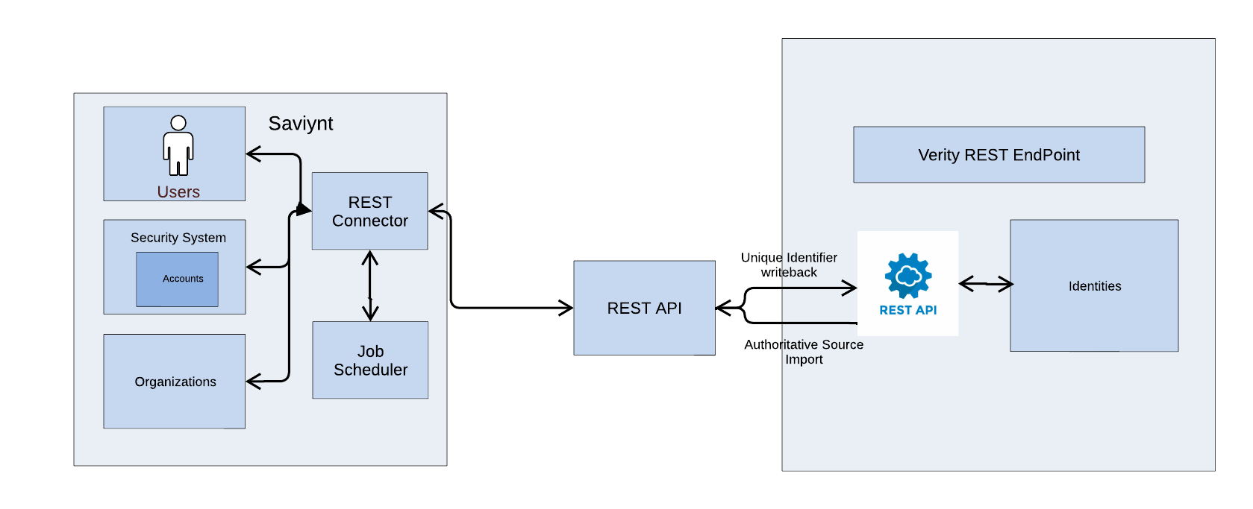
- Saviynt will receive new provider data from Verity for the users on their start date via the REST Connector implementation. Same connection will be used to aggregate the updates for the existing provider users too.
- Saviynt will generate the unique system login and use Customproperty1 to store the same.
- Attribute mapping Refer Appendix

19.4 Data PreProcessor:
Details | Purpose
"CUSTOMFUNCTION###FUNCTION1"  ],  "CUSTOMFUNCTIONS": {  "FUNCTION1": {  "FULLCLASSNAME": "com.sentara.custom.preprocessor.Transformation",  "METHODNAME": "doCustomPreprocessForVerity"  }  } | Purpose of this snippet of code is to generate the systemusername and the email address

19.5 Account Name Generation:
As mentioned in workday section 3.2.1

19.6 Email Generation:
Assumption:
- Saviynt will reconcile the Provider’s personal email id in the Saviynt Email field.
If the personal email address is not populated
Condition | Result
If no email existing | <samaccountname>@fakesentara.com

19.7 Reconciliation Jobs:
Name | details | Frequency
Verity_User_Import_full | User Import via a Connection which uses REST connection and the attribute mapping to bring new users / updates and termination feed. REST connector imports are only supported in Full mode. | Daily Multiple Times (Schedule TBD)

QNXT Integration
Sentara uses QNXT as claims processing application, QNXT helps Sentara manage claim inventory more efficiently by automating the process of prioritizing, triaging and reducing pending and exception claims. The result is streamlined claims adjudication management, reduced costs and improved speed, accuracy, efficiency, and compliance. In this phase of the project RBAC configurations will be created in Saviynt EIC to automatically create QNXT accounts with appropriate access. In current state provisioning to QNXT happens via Service Now ticket to the QNXT team after appropriate approvals are gained. There are different environments for QNXT which supports various functionalities QNXT.

20.1 Assumptions:
- QNXT team will provide store procedures for all provisioning actions:
  - Create
  - Disable
  - Update
  - Rehire
  - Delete (if supported)
- Account details for reconciliation:
- Unique Identifier
- First Name
- Last Name
- Status
- QNXT groups/entitlements
- Additional attributes TBD
- Each existing account will have “unique identifier” associated which will match with Saviynt user’s “unique identifier”.
- Orphan accounts will be mapped by Sentara team, any clean up of orphan accounts is the responsibility of Sentara.
- Only Sentara Health plan users are in scope for this implementation.
- All users who have access to QNXT and their access will be imported into Saviynt Production and Role Mining/Access Peer Analytics will be used by Sentara to come up with the role-based access criteria
- Technical rules will be created in Saviynt after role mining exercise is done and Sentara approves the criteria and associated QNXT entitlements

20.2 Prerequisite:
- DB connection details
- SC2.0 configuration to access DB server hosted in Sentara network.
- Local service account on the DB server is created and made available.
- Attribute Mapping details for QNXT

20.3 Connection Design
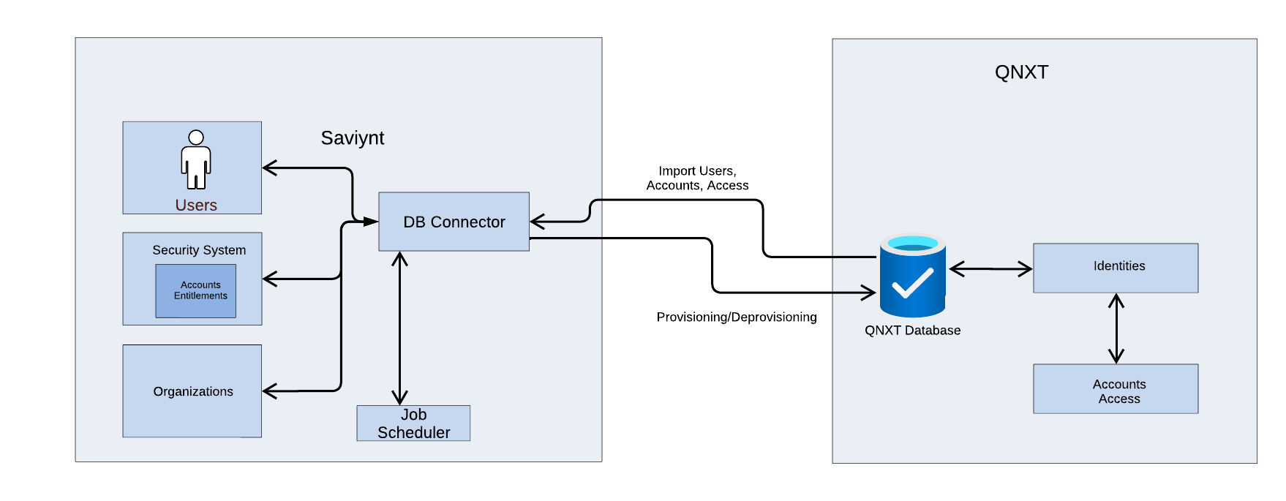
Saviynt will use the OOTB DB connector to integrate with the QNXT application.
The integration flow of QNXT database with Saviynt involves.
- EIC will import the user information at periodic intervals from the HR source.
- EIC creates/updates user records received from HR in the identity repository.
- EIC will initiate the birth right for QNXT accounts using technical rules.
- EIC will be configured to trigger QNXT account provisioning using DB Connector’s Stored Procedure for create/update/enable/disable operations.
- EIC will store all the event information for audit purposes.

20.4 Saviynt-QNXT Import Attribute Mapping
Refer appendix-TBD(pending from customer)

20.5 QNXT Account Management Processes
This section describes the account lifecycle process flow for QNXT applications.

Important Rules

Provisioning rule name | Condition
User correlation rule | Account.UniqueIdentifier = User. UniqueIdentifier
Account Name Rule | Account name generated via JAR utility

User Events

Event | Condition | Action
Import Accounts | Import accounts from QNXT | If match found Co-relate else create new account
New Hire | Account Request | Provision user to QNXT
Update User | IF(Any map user attribute updated) | Provision attribute updates to QNXT
Termination | User is disabled | Disable QNXT Account
Rehire | Rehired within 30 days of termination | Enable QNXT
 | Rehired after 30 days of termination | Create QNXT account with new System Login & email Attribute.

20.6 Reconciliation Jobs:
Name | details | Frequency
QNXT_User_Import_full | User Import via a Connection which uses DB connection and the attribute mapping to bring new users / updates and termination feed. DB connector imports are only supported in Full mode. | Daily Multiple Times (Schedule TBD)

EPIC integration
Epic is the EMR application being used as Sentara, design elements listed below presents a clear guide for the specific configurations and customizations for the integration of EMP into the Saviynt IAM System solution implemented for Sentara. Currently process to onboard the users into Epic is a manual process where the admins references an RBAC spreadsheet to onboard the users in Epic with right entitlements (linked templates and sub templates). RBAC content that is provided from Sentara will be optimized so that they can be ingested in Saviynt EIC as configurations.

21.1 Assumptions:
- Following Web services will be enabled on Epic EMP side.
  - Core Web Services Configuration
  - Personnel Management Web Services Configuration
  - Common Web Services Configuration
- Account details for reconciliation:
- Unique Identifier
- First Name
- Last Name
- Status
- Epic EMP templates/sub-templates
- Additional attributes TBD
- Each existing account will have “unique identifier” associated which will match with Saviynt user’s “unique identifier”.
- Orphan accounts will be mapped by Sentara team, any clean-up of orphan accounts is the responsibility of Sentara.
- Only following user types are in scope.
  - Employees
  - Contingent Worker
  - Community Provider?
  - Community Clinical staff
  - Research Monitor
- Technical rules will be created in Saviynt after optimization exercise to simplify the RBAC sheet and create configurations in Saviynt based on templates is done. Current RBAC criteria for Epic EMP can be found here
- Linked templates and sub-templates will be reconciled into Saviynt EIC as entitlements and will be made available to be configured in technical rules based on criteria.

21.2 Prerequisite:
- Epic EMP connection details
- Epic EMP service account details are provided
- Attribute Mapping details for Epic EMP

21.3 Connection Design
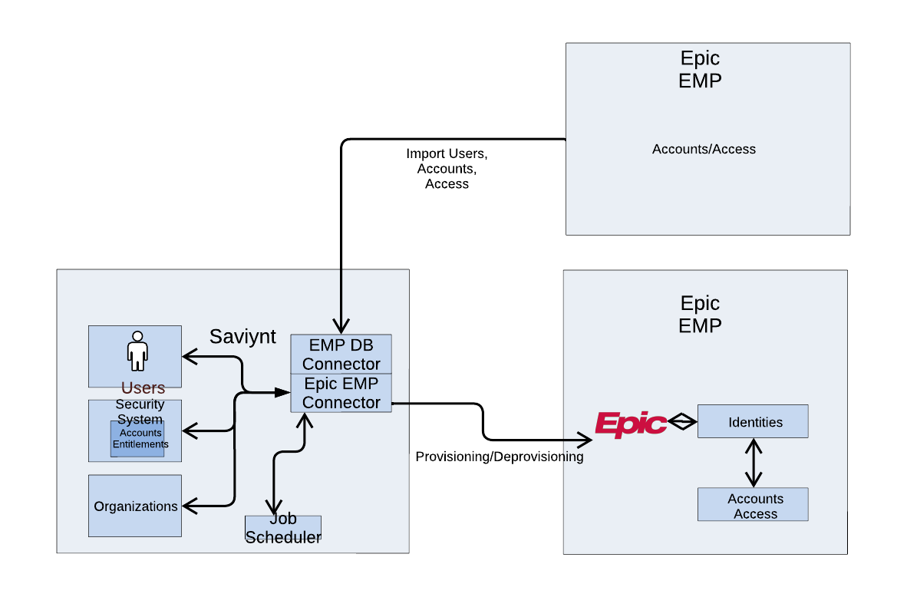
Saviynt will use the OOTB Epic EMP connector to integrate with the Epic EMP application.
The integration flow of Epic EMP database with Saviynt involves.
- EIC will import the user information at periodic intervals from the HR source.
- EIC creates/updates user records received from HR in the identity repository.
- EIC will initiate the birth right for Epic EMP accounts using technical rules.
- EIC will be configured to trigger EPIC account provisioning using OOTB Epic EMP for create/update/enable/disable operations.
- EIC will store all the event information for audit purposes.

2.14 Saviynt-EPIC EMP Import Attribute Mapping
Any attributes that is not present in Saviynt, or cannot be calculated will be excluded from the below list
NAME | ITEM#
USER NUMBER | EMP.1
USERNAME | EMP.2
FIRST NAME | EAM 1030
MIDDLE NAME | EAM 1040
LAST NAME | EAM 1010
SUFFIX | EAM 1080
STATUS | EMP 50
EFFECTIVE FROM DATE | EMP 720
EFFECTIVE TO DATE | EMP 730
USER ALIAS | EMP 180
EMAIL ADDRESS | EMP 150
LINKABLE TEMPLATES | EMP 1110
LINKABLE TEMPLATES EFFECTIVE FROM DATE | EMP 1111
LINKABLE TEMPLATES EFFECTIVE TO DATE | EMP 1112
LINKABLE TEMPLATES LOGIN TYPES | EMP 1115
DEFAULT LINKABLE TEMPLATE | EMP 1101
LINKED SUBTEMPLATES | EMP 9205
RPT GRP ONE | EMP 280
HYPERSPACE LOGIN DEPARTMENT | EMP 20660
CLASSIFICATIONS | EMP 450
REPORTING AUTHORIZED SERVICE AREAS | EMP 29080
CONFIGURATION FOR USER | EMP 17030
MR CLASS DEPARTMENT | EMP 17310
MR DEPARTMENT BASED SEC CLASS | EMP 17300
MR RESTRICTED ACCESS | EMP 17320
EL ACCESS DEACTIVATED? | EMP 22005
USER CONTEXTS | EMP 22210
SITE MANAGER CONTEXTS | EMP 22215
CADENCE DEPARTMENT | EMP 5100
CADENCE DEPARTMENT SECURITY LEVEL | EMP 5105
CADENCE DEPARTMENT PRIVATE SLOTS | EMP 5107
EXTERNAL ACCOUNT | EMP 20350
RETURN ADDRESS | EMP 20330

21.5 Epic EMP Account Management Processes
This section describes the account lifecycle process flow for EMP applications.

Important Rules

Provisioning rule name | Condition
User correlation rule | Account.UniqueIdentifier = User. UniqueIdentifier
Account Name Rule | Account name generated via JAR utility(User profile systemusername)

User Events

Event | Condition | Action
Import Accounts | Import accounts from Epic EMP | If match found Co-relate else create new account
New Hire | Account Request | Provision user to Epic EMP
Update User | IF(Any map user attribute updated) | Provision attribute updates to EMP
Termination | User is disabled | Disable Epic Account
Rehire | Rehired within 30 days of termination | Enable Epic
 | Rehired after 30 days of termination | Create Epic account with new System Login & email Attribute.

21.6 Reconciliation Jobs:
Name | details | Frequency
Epic_EMP_User_Import_full | User Import via a Connection which uses Epic EMP connection and the attribute mapping to bring new users / updates and termination feed. | Daily Multiple Times (Schedule TBD)

EMAIL TEMPLATES

Assumptions
- For email encryption, custom O365 rule would be used based on email subject/body content.
- Customer will provide mailbox

Type | Event | Content
AD -> Account and password sharing | Successful AD account creation
Duo enrollment | Successful DUO account creation
User termination email to manager | User terminated in AD for employees and contingent workers only
Account expiration email to relationship | Report based trigger before 60/30/14/7/1 days of reaching end date for Extended learner

Welcome email/account claiming email sent to the end-user
Dear ${user.firstname} ${user.lastname},
Welcome and Congratulations!
We’re excited that you are joining the Sentara Team! Please follow the steps below according to your role, as soon as possible, to ensure that you have sufficient time to complete all your required onboarding tasks and prevent delays. Please see the instructions below appropriate for your role.
Your Network Login is: ${user.username}
Your Temporary Network password is: ${randompassword}
Your Email is: ${user.email}
Step 1
<instructions to self-register into password reset application>
Step 2
Obtain your physical access badge by visiting the Sentara Physical Security office located at the main hospital to have your picture taken and be given the badge.
Step 3
<Instructions to complete the learning/orientation courses>
Step 4 (Optional)
If you need access to any additional applications, please ask your Sentara sponsor/supervisor to submit a request via the Service Now request system. Alternatively, you can contact the Help Desk at xxx-xxx-xxxx and make a request which will then be routed to your supervisor for approval.
Again, congratulations on your new opportunity and welcome to Sentara!
Sentara Human Resources

Account expiration notice email sent to the relationship group
Subject: ${user.<uniqueSystemLogin>} Account is expiring in 30 days / 15 Days / 1 day
The relationship of type NonEmployee for ${user.firstname} ${user.middlename} ${user.lastname} (${user.<uniqueSystemLogin>}) will expire within 30 days.
You can allow the relationship to expire or extend the relationship expiration date by contacting (Manager group).

User termination email sent to the user's manager
Subject: ${user.<uniqueSystemLogin>} Account has expired
Message
The relationship of type ${user.CPrelationship} for ${user.firstname} ${user.middlename} ${user.lastname} (${user.<uniqueSystemLogin>}) has expired. All roles and groups have been removed.

If access is still required, please contact the (Manager Group) Team to request a new invitation for access. The account will no longer be usable in 30 days.

Appendix

ALl the attributes that are needed for the Phase 2/Wave 2 implementation can be found in the master attribute list in Teams
Workday Attribute | SecZetta Attribute | Echo Attribute | Saviynt Attribute | PSDB Attribute | PSDB Notes | AD Attribute | AD Transformation/notes | SNOW Attribute | SNOW Transformation | DUO Attribute
EmplID | <TBD> | N/A | Employee ID | Job.EmplID (varchar(20), not null) |  | employeeNumber |  | employee_number
BirthDate | DOB |  | Date of Birth | Person.DOB (datetime, null) |  | N/A
RecordType | Relationship |  | Relationship | Instance.ItemId (int, not null, FK)
 |  |  |  | Instance.RecordStatus (tinyint, not null, FK)
 |  |  |  | Job.LastAction (datetime, null)
 |  |  |  | CorpPerson.TypeID (int, not null, FK)
EmployeeStatus (CF_-_INT0026_-_Eval_-_Employee_Status_-_On_-_Worker) | Status | Status | Employment Status | Instance.RecordStatus (tinyint, not null, FK) |  | userAccountControl |  | active, u_status |  | Status | no transformation to PSDB
FirstName | First Name | drname.dr_fname | First Name | Person.FirstName (varchar(30), not null) |  | givenName |  | first_name | Camelcase, no middle initial | First Name
LastName | Last Name | drname.dr_fname | Last Name | Person.LastName (varchar(30), not null) |  | sn |  | last_name | Camelcase | Last Name
MiddleName |  |  | Middle Name | Person.MidName (varchar(15), null) |  | N/A |  | middle_name | Camelcase
Suffix |  |  |  | Person.Suffix (varchar(3), null) |  | N/A
PreferredFirstName,PrefrerredLastName | PreferredFirstName |  | Preferred First Name | CorpPerson.NickName (varchar(20), null) |  | displayName |  | Preferred Name
PreferredFirstName,PrefrerredLastName | PreferredLastName |  | Preferred Lirst Name | Person.NickName (varchar(30), null) |  | displayName
Gender |  |  | Gender | Person.Gender (char(1), null) |  | N/A
PhoneType |  |  | PhoneType | PersonPhone.PhoneTypeId (int, not null, FK) |  | N/A
PhoneNumber |  |  | PhoneNumber | Phone.PhoneNbr (char(20), not null) |  | telephoneNumber |  | phone
JobCode |  |  | JobCode | Job.JobCode (varchar(10), null) |  | N/A |  | u_job_code
 |  |  |  | JobInfo_PS.JOBCODE (varchar(8), not null)
JobTitle =Position title for position  if its blank its job profile title |  |  | JobTitle | Job.JobTitle (varchar(40), null) |  | Title |  | title
 |  |  |  | JobInfo_PS.DESCR (varchar(50), not null) |  | Title
CompanyID |  |  | CompanyID | UDAKEntity.EntityTextID (varchar(12), null) |  | departmentNumber |  | u_company_id
CompanyDescription (Company_-_Name) |  |  | CompanyDescription (Company_-_Name) | UDAKEntity.EntityDescr (varchar(120), null)
CostCenterID |  |  | CostCenterID | UDAKDept.DeptTextID (varchar(12), null) |  | departmentNumber
CostCenterdescription (Cost_Center_-_Name) |  |  | CostCenterdescription | UDAKDept.DeptDescr (varchar(120), null) |  | department
ReportingID |  |  | ReportingID | UDAKLocator.LocatorTextID (varchar(12), null) |  | departmentNumber |  | u_department_id
ReportingDescription |  |  | ReportingDescription | UDAKLocator.LocatorDescr (varchar(120), null)
LocationID (CF_-_LRV_-_Location_Ref_ID_-_On_-__Worker) |  |  | LocationID | PhysicalWorkLocationMaster.LocationCode (varchar(5), not null) |  | physicalDeliveryOfficeName |  | u_location_id
LocationName |  |  | LocationName | PhysicalWorkLocationMaster.LocationDescription (varchar(50), not null) |  |  |  | location
LocationAddress1 |  |  | LocationAddress1 | Address.Address1 (varchar(35), null) |  |  |  | street
LocationAddress1 |  |  | LocationAddress1 | PhysicalWorkLocationMaster.Address1 (varchar(35), null)
LocationAddress2 |  |  | LocationAddress2 | Address.Address2 (varchar(35), null)
LocationAddress2 |  |  | LocationAddress2 | PhysicalWorkLocationMaster.Address2 (varchar(35), null)
LocationCity |  |  | LocationCity | Address.City (varchar(35), null) |  |  |  | city
LocationCity |  |  | LocationCity | PhysicalWorkLocationMaster.City (varchar(35), null)
LocationState |  |  | LocationState | Address.StateProvince (varchar(15), null) |  |  |  | state
LocationState |  |  | LocationState | PhysicalWorkLocationMaster.State (varchar(2), null)
LocationZip |  |  | LocationZip | Address.PostalCode (char(10), null)
LocationZip |  |  | LocationZip | PhysicalWorkLocationMaster.PostalCode (varchar(10), null)
Workshift |  |  | Workshift | Job.WorkshiftId (int, null)
ManagerID |  |  | ManagerID | Job.SupervisorID (int, null) |  | manager |  | manager | User login of manager
ManagementLevel |  |  | ManagementLevel | Job.EmployeeRoleID (int, null, FK) |  |  |  | u_company_role
EmailType |  |  | EmailType | PersonEmail.EmailTypeId (int, not null, FK)
EmailAddress | email |  | EmailAddress | Email.EmailAddress (varchar(100), not null) |  | mail |  | email |  | Email
AddressType |  |  | AddressType | PersonAddress.AddressTypeId (int, not null, FK)
Address1 |  |  | Address1 | Address.Address1 (varchar(35), null)
Address2 |  |  | Address2 | Address.Address2 (varchar(35), null)
City |  |  | City | Address.City (varchar(35), null)
State |  |  | State | Address.StateProvince (varchar(15), null)
Zip |  |  | Zip | Address.PostalCode (char(10), null) |  |  |  | zip
UniqueIdentifier | UniqueIdentifier | N/A | Unique Identifier |  |  | extensionAttribute8 | N/A
Relationship |  |  | Relationship | Person.SourceSystem (varchar(20), not null) |  |  |  | source
Hire Date |  |  | Hire Date | Person.AddDate (smalldatetime, not null)
End date |  |  | End date | PersonAddress.RecordStatusId (tinyint, not null)
 |  |  |  | PersonAddress.PersonId (int, not null, FK)
 |  |  |  | PersonAddress.AddressId (int, not null, FK)
 |  |  |  | PersonEmail.RecordStatusId (tinyint, null)
 |  |  |  | PersonEmail.PersonId (int, not null, FK)
 |  |  |  | PersonEmail.EmailId (int, not null, FK)
 |  |  |  | PersonPhone.RecordStatusId (tinyint, null)
 |  |  |  | PersonPhone.PersonId (int, not null, FK)
 |  |  |  | PersonPhone.PhoneId (int, not null, FK)
 |  |  |  | Instance.CreateDate (datetime, not null)
 |  |  |  | Instance.UpdateDate (datetime, not null)
 |  |  |  | Instance.ItemId (int, not null, FK)
 |  |  |  | Instance.InstanceDesc (varchar(255), not null)
 |  |  |  | Instance.RecordStatusDate (datetime, not null)
 |  |  |  | Instance.PersonId (int, null)
 |  |  |  | Instance.AccountId (int, null, FK)
 |  |  |  | CorpPerson.PersonId (int, not null)
 |  |  |  | CorpPerson.LastChangeDate (datetime, null)
 |  |  |  | CorpPerson.OrigDate (datetime, null)
 |  |  |  | CorpPerson.SourceSystem (varchar(20), null)
 |  |  |  | CorpPerson.AddDate (smalldatetime, null)
 |  |  |  | CorpPerson.ValidatedEmployee (smallint, not null)
 |  |  |  | Job.RecordId (int, not null)
 |  |  |  | Job.CorpPersonId (int, not null, FK)
 |  |  |  | Job.LastActionDate (datetime, null)
 |  |  |  | Job.LastChangeDate (datetime, null)
 |  |  |  | Job.OrigDate (datetime, null)
 |  |  |  | Job.DeptId (int, null, FK)
Job Category |  |  | Job Category |  |  | extensionAttribute4
Job Family Group |  |  | Job Family Group |  |  | extensionAttribute5
Job Level |  |  | Job Level |  |  | extensionAttribute6
Job Profile ID |  |  | Job Profile ID |  |  | extensionAttribute7
 |  |  |  |  |  | extensionAttribute13 | Computed from IGA, if O365 is poulated, account will be synced to Azure AD
country code |  |  | country code |  |  |  |  | country
reporting_division |  |  | reporting_division |  |  |  |  | department
UserLogin |  |  | User Login |  |  | samAccountName |  | user_name |  | Username
 |  |  |  |  |  |  |  | u_contingent_worker | 1 if contingent worker
fax_work_phone_number |  |  | fax_work_phone_number |  |  |  |  | u_fax
hire_date |  |  | hire_date |  |  |  |  | u_hire_date
 |  |  |  |  |  |  |  | u_is_manager | 1 if manager
pager_work_phone_number |  |  | pager_work_phone_number |  |  |  |  | u_pager
position_worker_type |  |  | position_worker_type |  |  |  |  | u_type
worker_type* |  |  | Relationship in Saviynt |  |  | EmployeeType
.

